**Flower shop**

**About of my site:**

**It is a site for show the flowers and allow the customer to buy them**

**For user:**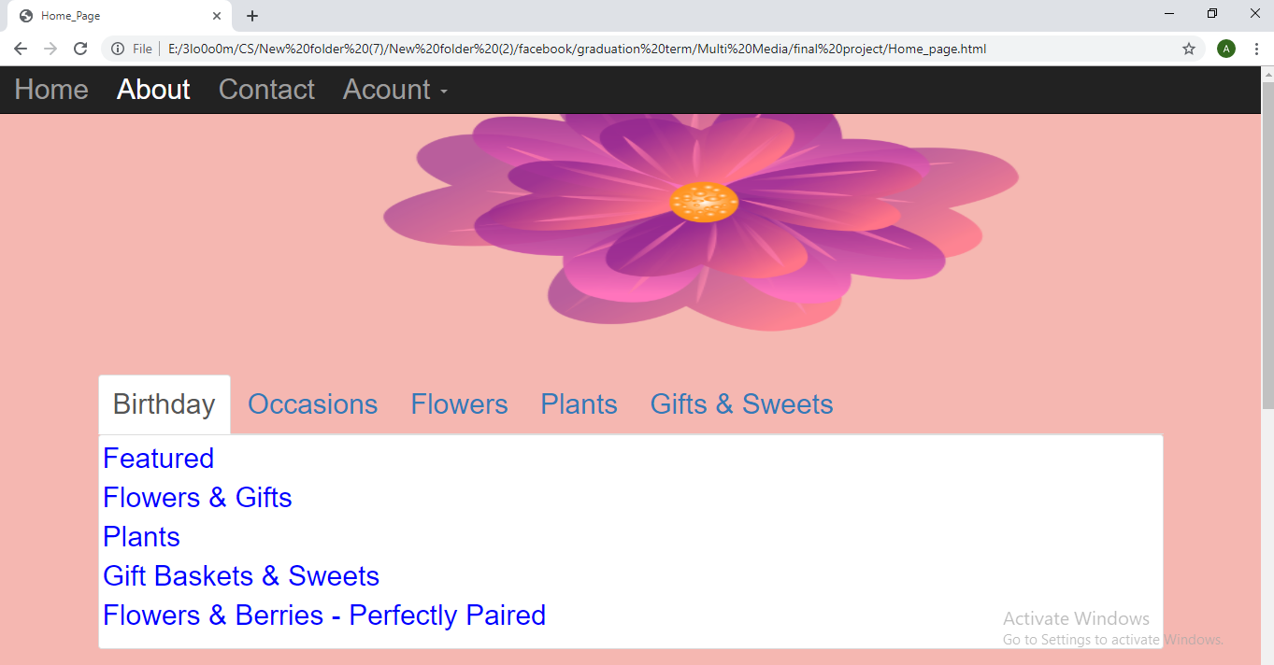

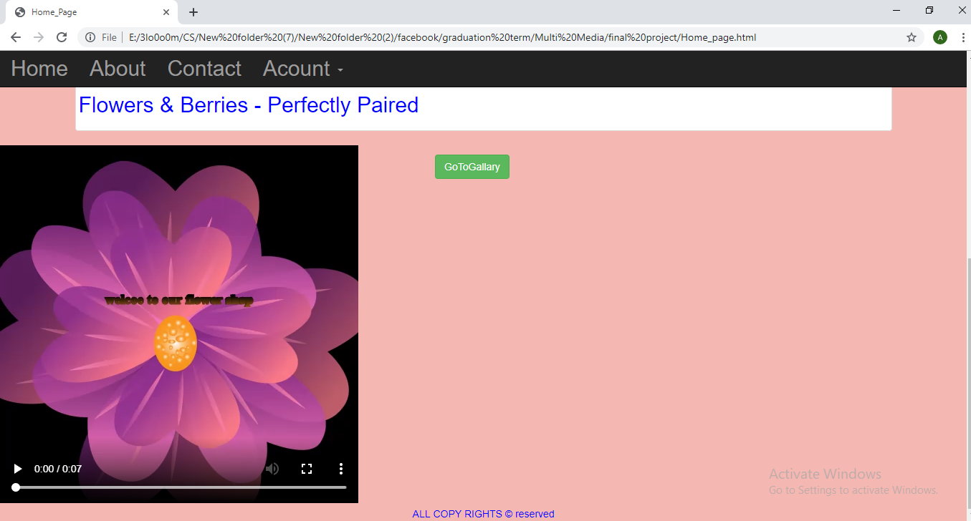

**It is the home page of the site from it the customer can to go to any page.**

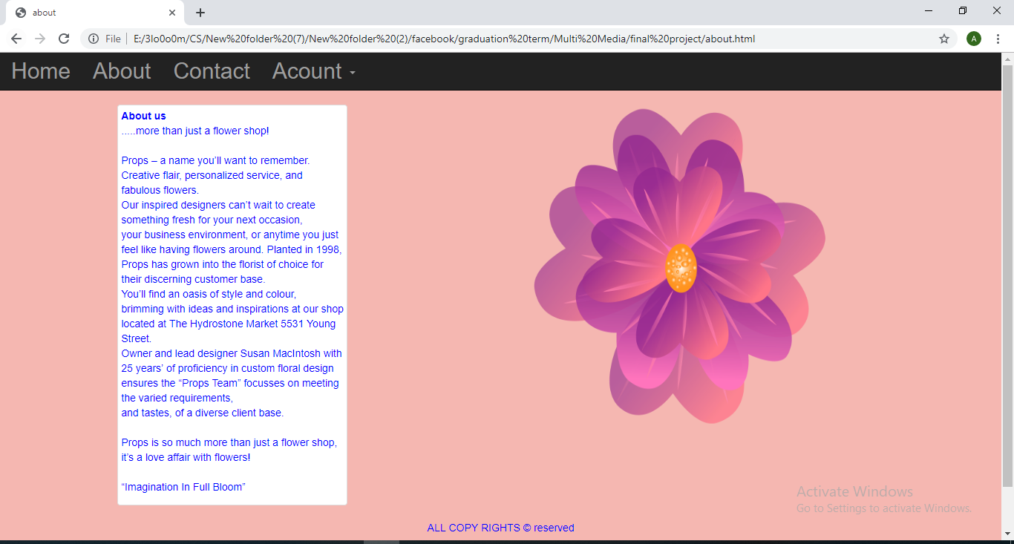

**This page contains information about the flower shop.**

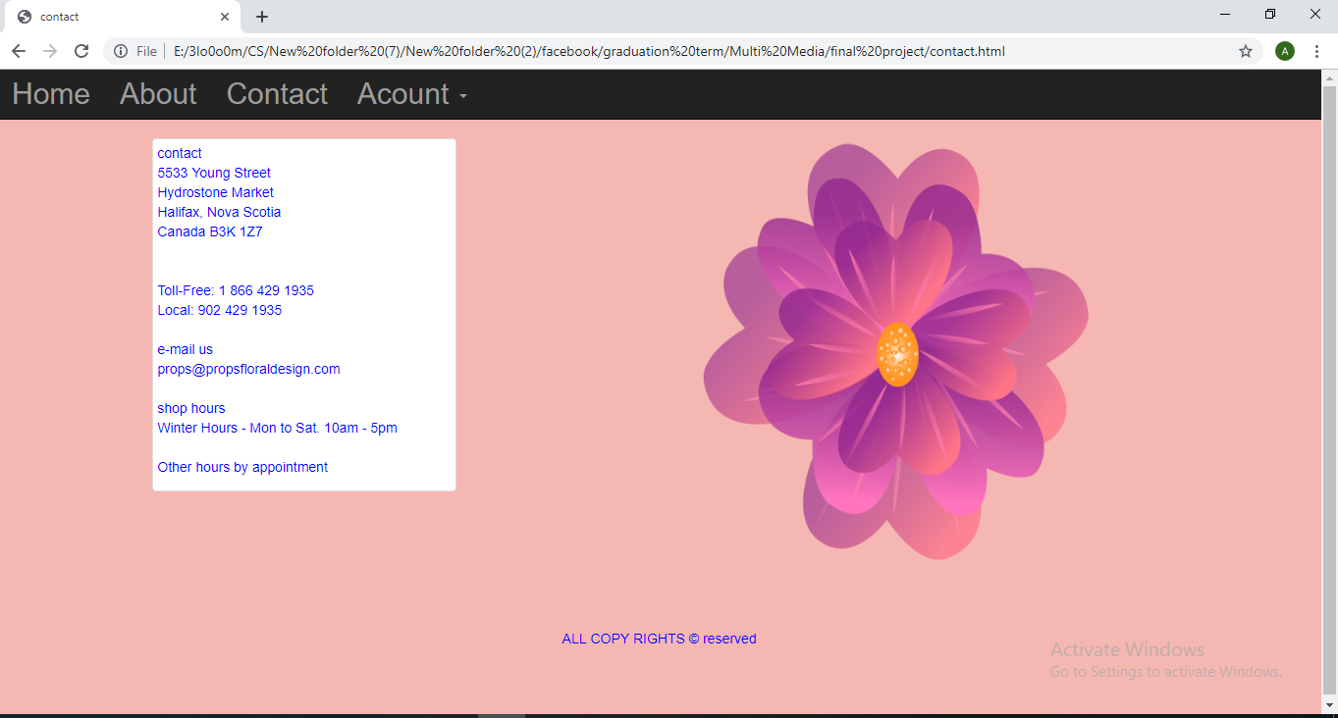

**This page contains information of how the customer can contact with the owner of the flower shop.**

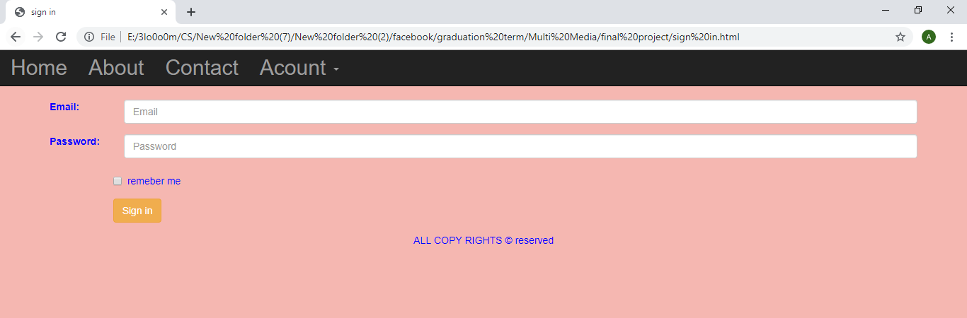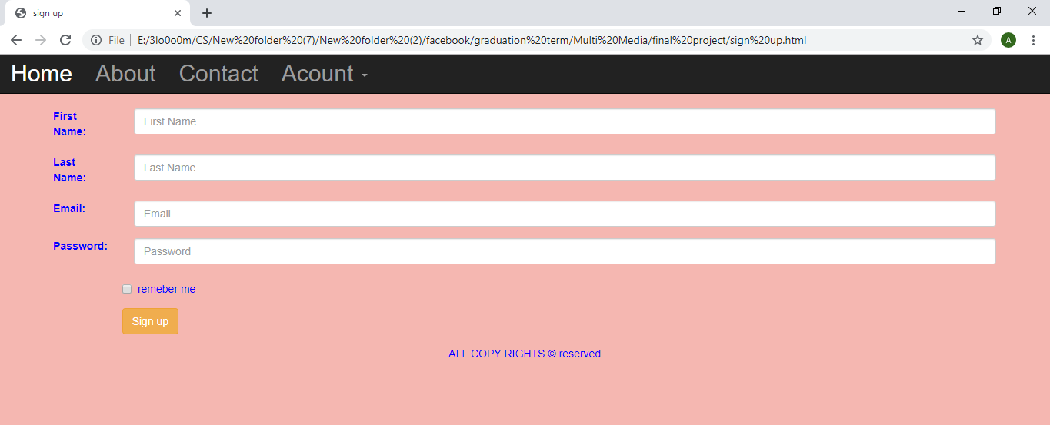

**By there the customer can make account on the site.**

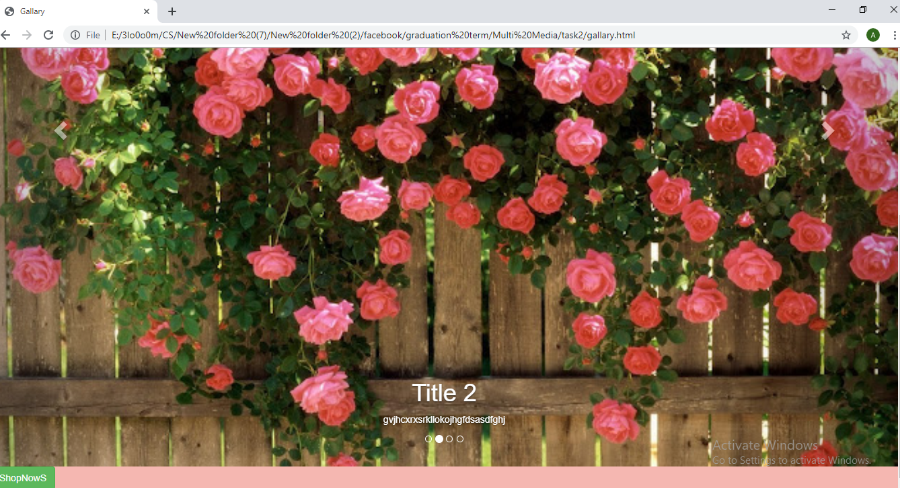

**It is the gallery of site to show our work.**

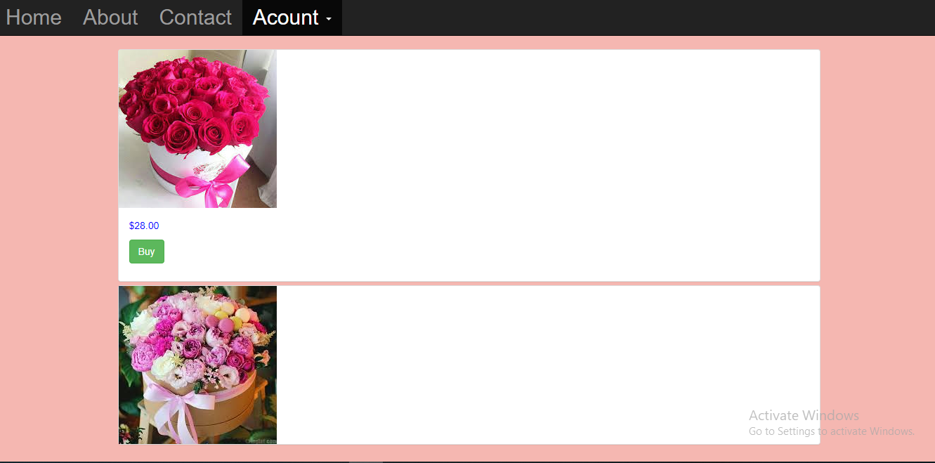

**In this page the customer can buy what he want.**